PROLOG LAB EXPERIMENTS

Experiment 26: Write a Prolog Program to Sum the Integers from 1 to n
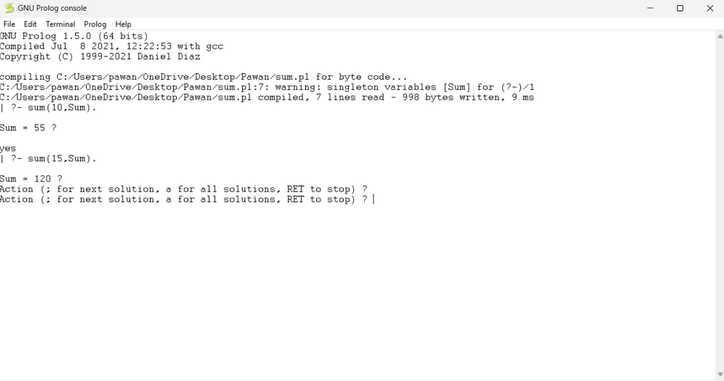

Experiment 27: Write a Prolog Program for A DB WITH NAME, DOB.
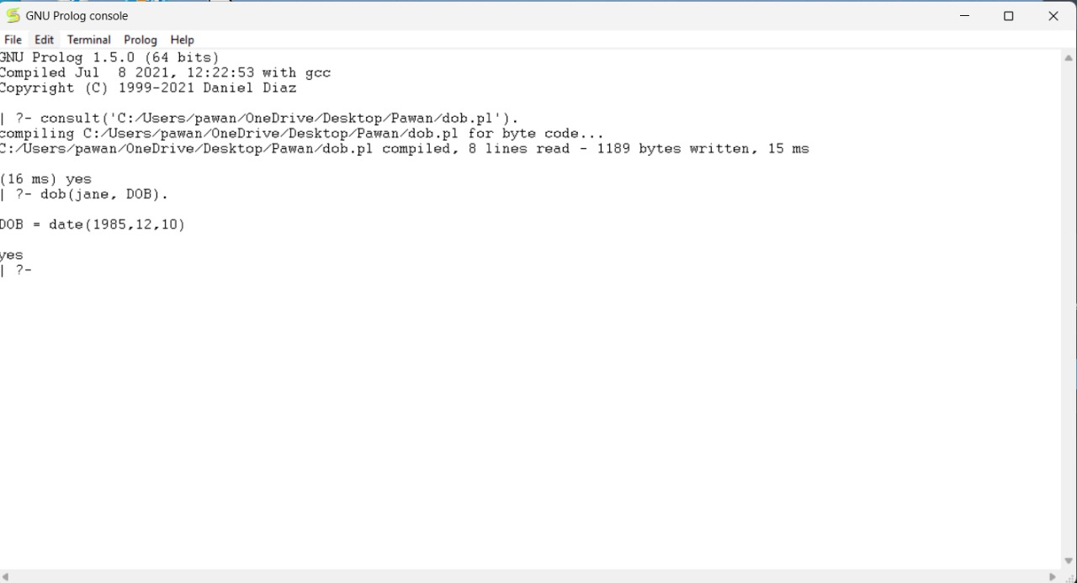

Experiment 28: Write a Prolog Program for STUDENT-TEACHER-SUB-
CODE.
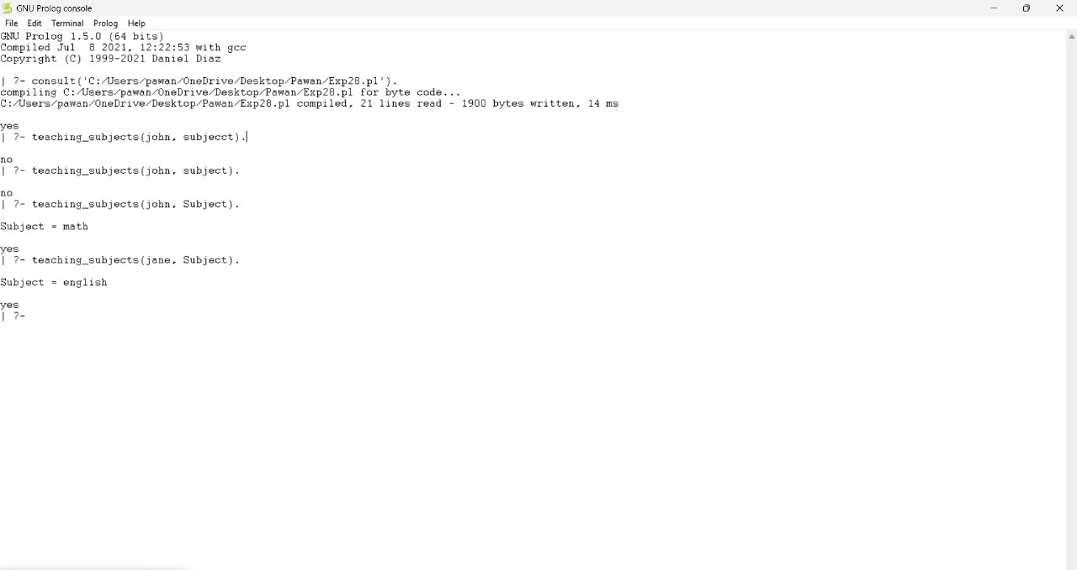

Experiment 29: Write a Prolog Program for PLANETS DB Program.
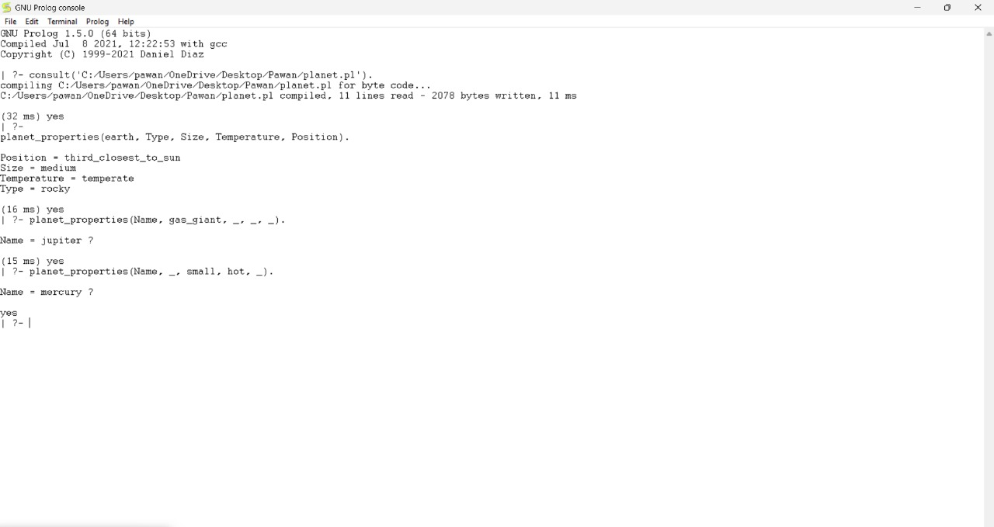

Experiment 30: Write a Prolog Program to implement Towers of Hanoi
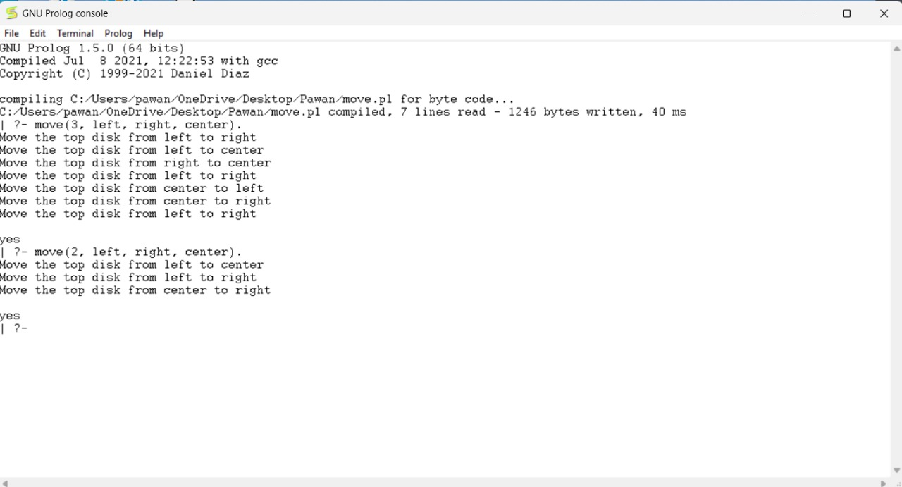

Experiment 31: Write a Prolog Program to print particular bird can fly or not. Incorporate required query
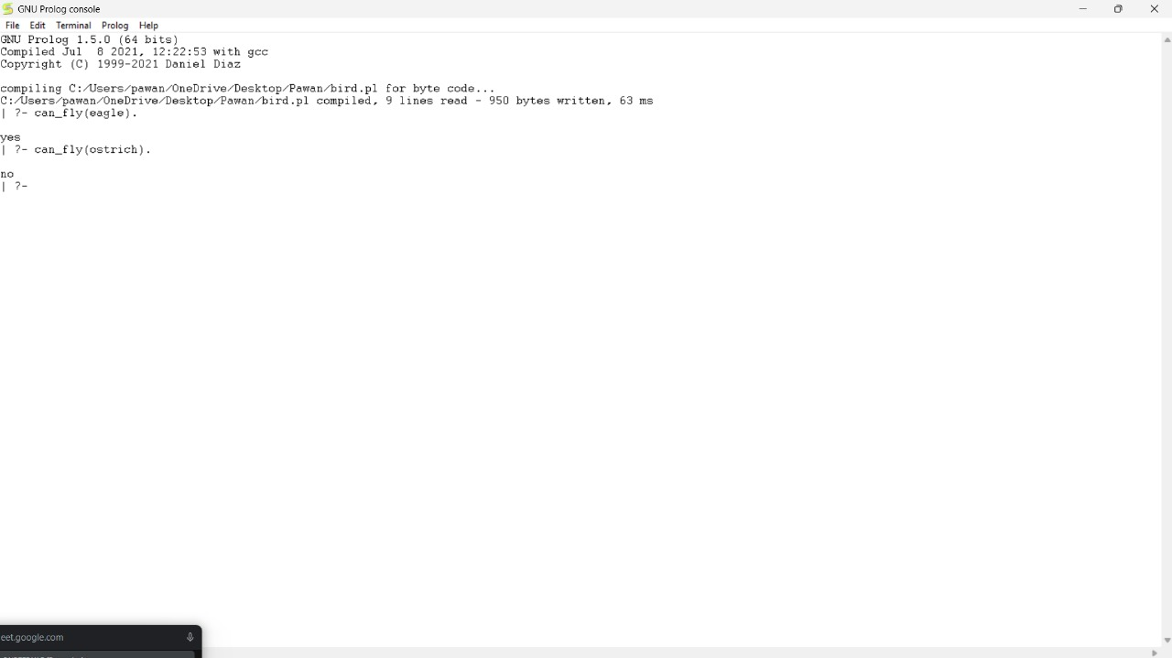

Experiment 32: Write the Prolog program to implement family tree Pam, Liz, Ann and Pat are female, while Tom, Bob and Jim are male persons. Using this information, define the following relations: • Define the “mother” relation: • Define the “father” relation: • Define the “grandfather” relation: • Define the “grandmother” relation: • Define the “sister” relation • Define the “brother” relation
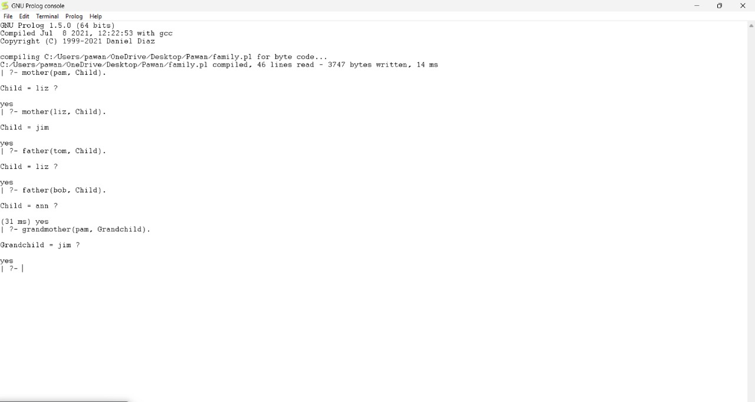

Experiment 33: Write a Prolog Program to suggest Dieting System based on Disease.

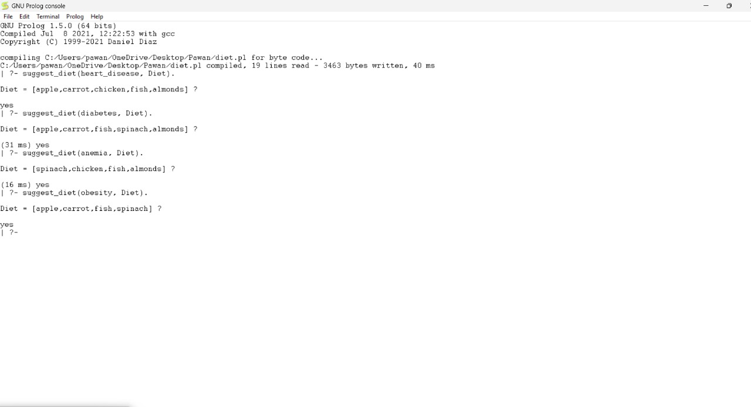
Experiment 34: Write a Prolog program to implement Monkey Banana Problem
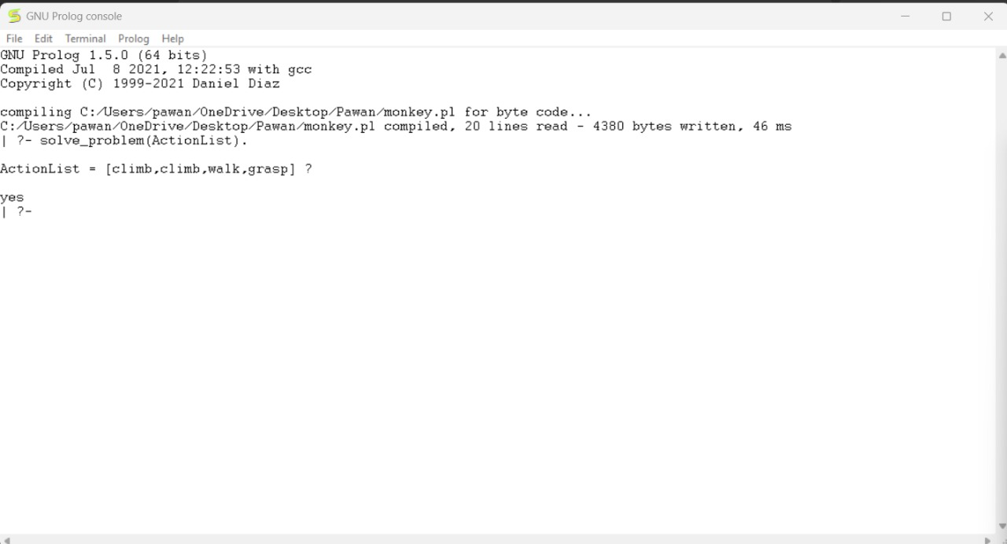
Experiment 35: Write a Prolog Program for fruit and its color using Back Tracking.

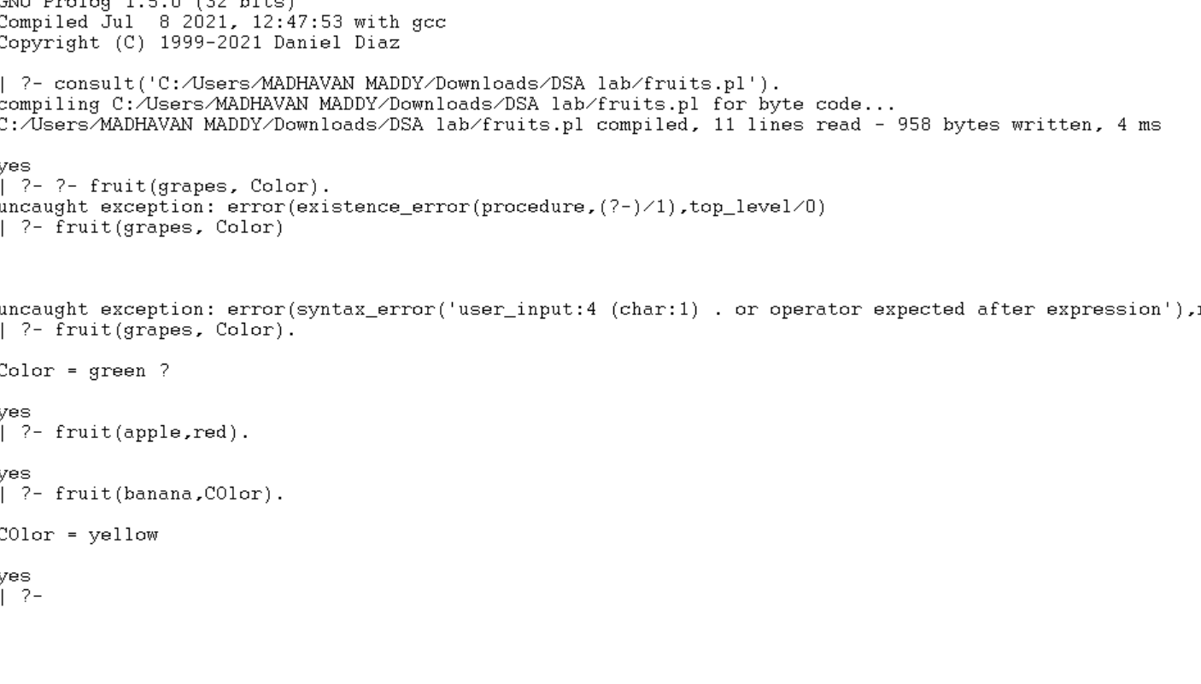

Experiment 36: Write a Prolog Program to implement Best First Search algorithm
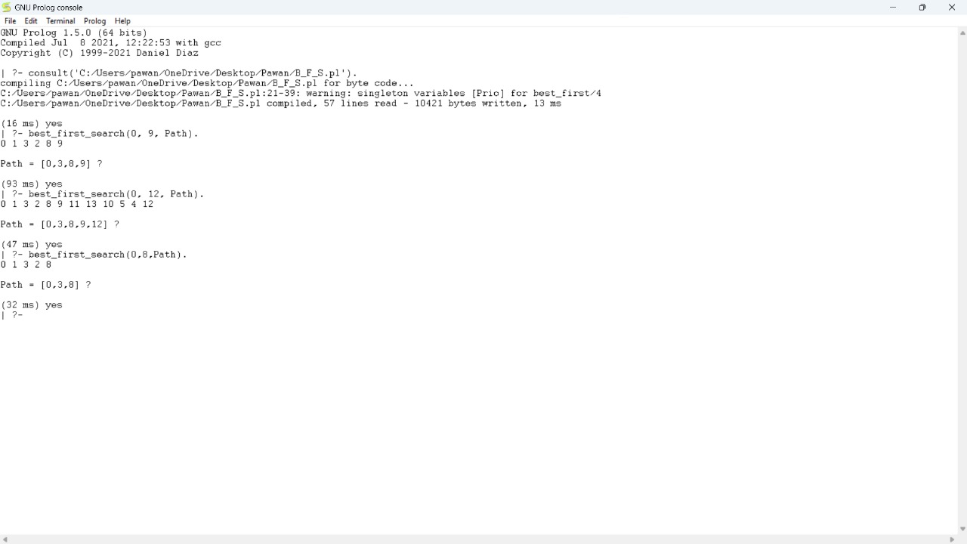

Experiment 37: Write the Prolog program for Medical Diagnosis.
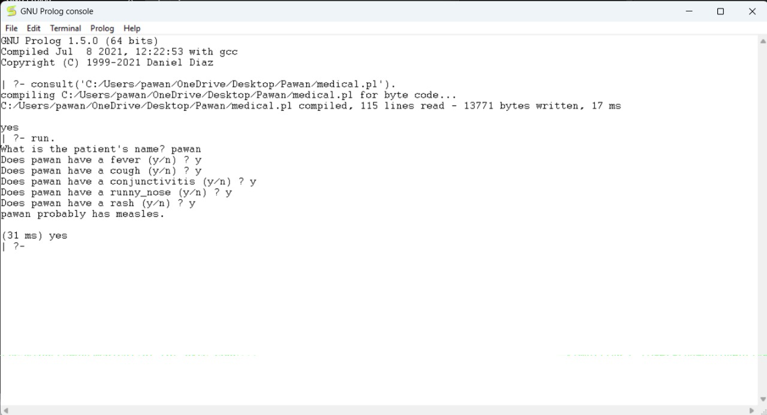

Experiment 38: Write a Prolog Program for forward Chaining. Incorporate required queries.
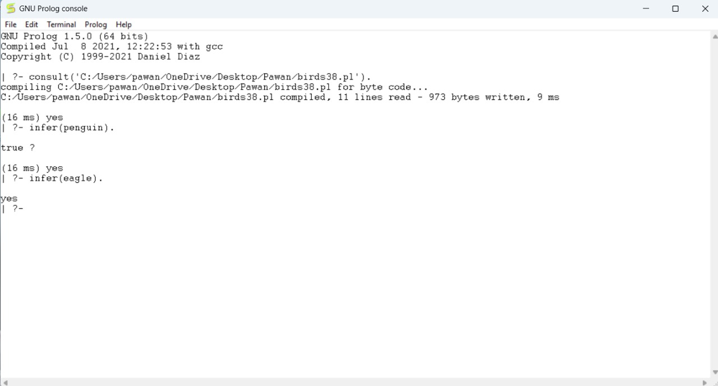

Experiment 39: Write a Prolog Program for Backward Chaining. Incorporate required queries.
